Contents
1 Project 3
1.1 Project 3
1.2 Description 3
1.3 Revision History 3
2 Overview 4
2.1 Purpose 4
2.2 Scope 4
2.3 Requirements 4
2.3.1 Traceability Matrix 4
3 System Architecture 5
3.1 Hardware Requirements: 5
4 Data Design 6
4.1 Persistent Data 6
4.1.1 Dataset 6
4.1.2 Static Data 7
4.1.3 Persisted data 7
4.2 External Interface Data 7
4.2.1 RabitMQ : 7
4.3 Transformation of Data 7
4.3.1 ApplicationUpdate : 7
5 Software Domain Design 8
5.1 Software Application Domain Chart 8
5.2 Software Application Domain 9
5.2.1 Sub Component 9
5.2.2 Class Diagram 10
5.2.3 Use Cases 11
5.2.4 Deployment Diagram 14
6 Other Interfaces 14
7 Outstanding Issues 14
8 Non Functional Requirement 15
9 References 15
10 Glossary 15

Project

Project

Mosambee is an EMV enabled comprehensive mobile (POS) Point of Sale system providing end to end payment solutions for Debit and Credit Card transactions. NI Digital Onboarding integrate with Mosambee for onboarding all the SoftPOS merchants on their platform

Description

- Currently, the bulk onboarding of SoftPOS merchants into the Mosambee requires generation of one file which will be processed via CTRL-M jobs. Going forward we will no longer use the file based processing.
- NI SoftPos merchants will be onboard into the Mosambee using SoftPos Mosambe API’s. API’s are Rest API’s and will be triggering via the internet after encrypting the data. The corresponding IP/URL’s should be whitelisted before production deployment.

Revision History
Date | Comment | Author
17 Jan 2023 | Initial Draft | Sudesh Mane

Overview

Purpose

The purpose of the document is to provide support to onboard the merchant and terminal ids using the Mosambee API mechanism. The scope of this document is to provide the API specification for merchant, Terminal onboarding. IP whitelisting is required to perform the API operation.

Scope
Adapter – Adapter invoke Mosambee Rest API with the help of HMAC authentication
Mosambee - provides JSON based rest API connectivity to the client for integration with configuration (merchant profile, MID and TID setup) service.

Requirements
Break down the requirements to provide a ballpark estimate.

Traceability Matrix
Cross reference this document with your requirements document and link where you satisfy each requirement
SRS Requirement | SDD Module
Req 1 | [NASSC-2644] NGenius One - Soft POS API - Jira (atlassian.net)

System Architecture
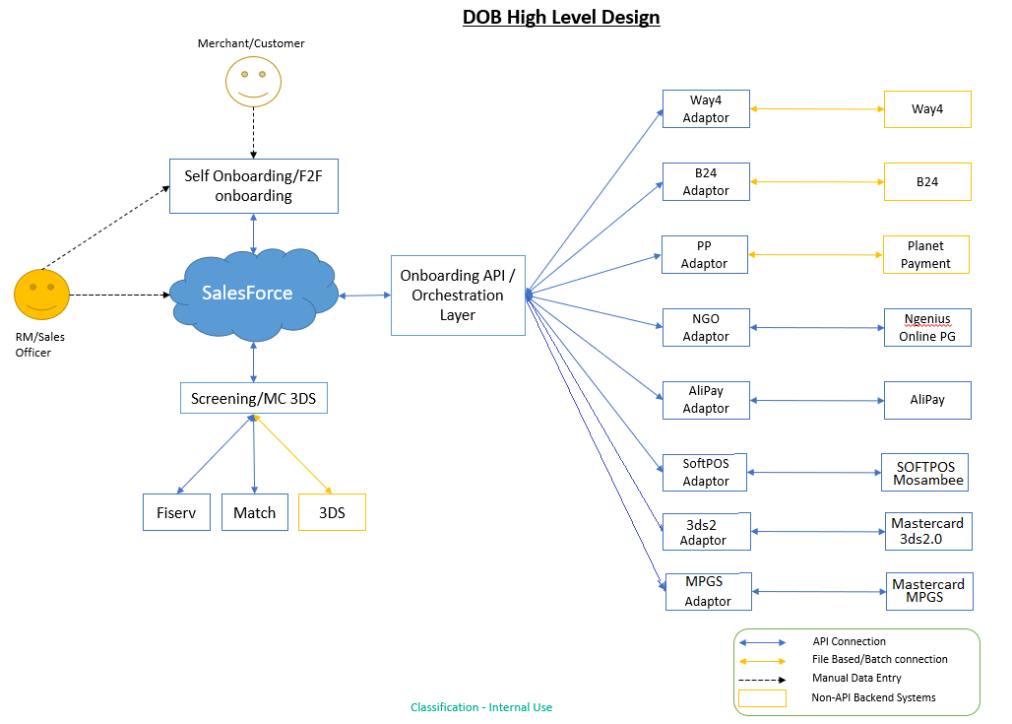

Hardware Requirements:
Standard Server config | ELK Server (if no shared service available)
RHEL 7 (or latest available) | RHEL 7 (or latest available)
8 core cpu | 8 core cpu
80GB storage | 1000GB storage
32GB memory | 32GB memory

  - Software Requirements:
Component | Infrastructure | Licensing
Java 8 | 2 RHEL Linux server | Commercial license, Included with server provisioning
RabbitMQ Cluster | same servers | We use free open-source version, commercial version is available with a subscription fee for support.
Selenium | same servers | Free
Ansible | 1 server | Free, commercial support available
ELK | 3 servers | Free, commercial subscription available
MongoDB | 2 servers | Free, commercial support available

Data Design
Describe the data contained in databases and other shared structures between domains or within the scope of the overall project architecture

Persistent Data
Describe/illustrate the logical data model or entity relationship diagrams for the persistent data

- BusinessProfile
businessLegalName
businessDbaName
businessContactNumber
businessEmail
businessSpocName
businessAddress
businessCity
businessState
businessPin
businessCategoryCode
- midDetails
merchantCode
instrument
acquirer
tg
  - tidDetails
terminalId
userName
tidType
storeName
terminalLocation
posTerminalSupport
devicePairFlag
terminalAuthType
terminalKeyValue
terminalSpocName
terminalContactNo
terminalEmail

Dataset
Describe persisted object/dataset and its relationships to other entities/datasets
- Acquirer Config
acquirers:
NI:
name: NI
id: 200
TYME:
name: TYME BANK
id: 451

Static Data
instrument = "card"
tidType = "both"
devicePairFlag = "N"
terminalAuthType = "none"

Persisted data
- Collection - octopusdb.softpos_mosambee_requests
- Payload
- APIData
  - requestCall
  - responseCall
- Task
  - TaskHistory

External Interface Data
Any external interfaces’ data goes here (this is for the data, section 8 is for the interface itself)

RabitMQ :
- Configuration
- Name :- softpos
- routingKeys :- routing.backend.softpos

Transformation of Data
Describe any data transformation that goes on between design elements

ApplicationUpdate :
- Configuration
- BackendSystem :- SOFTPOS
- ApplicationId :- Id of payload
- AdditionalData
  - profileResponse- response of api call

Software Domain Design

Software Application Domain Chart



Software Application Domain

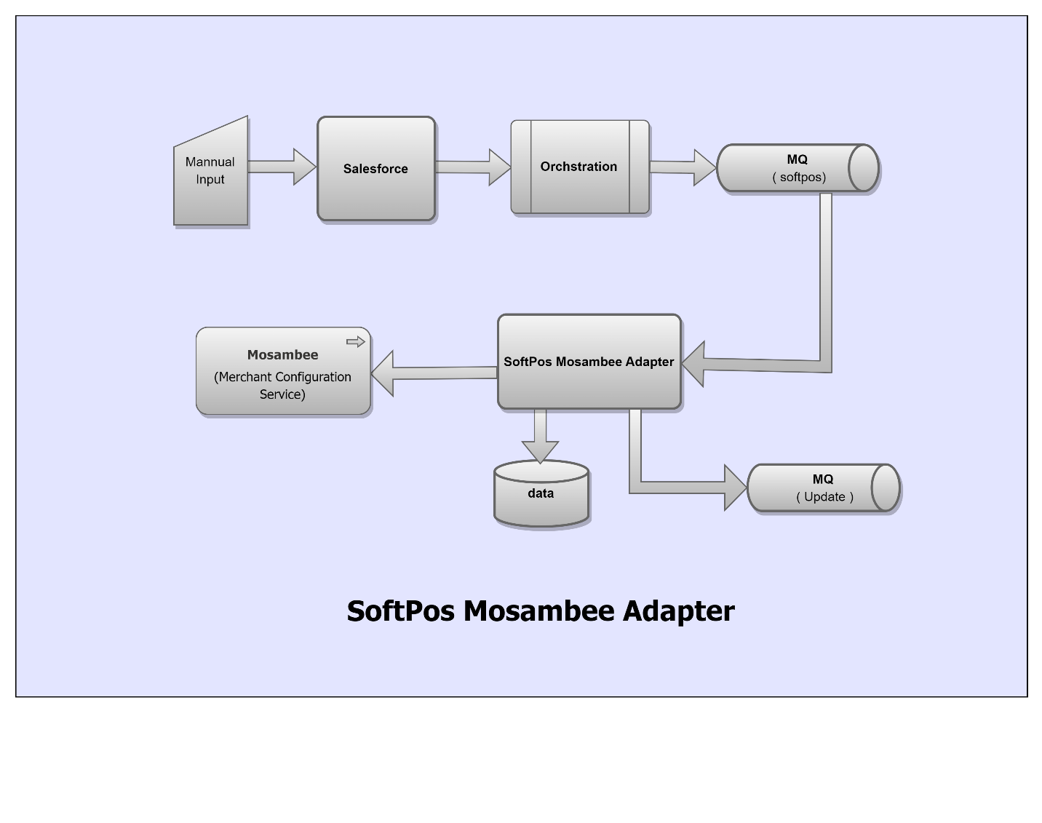

Sub Component
- Salesforce - User will provide inputs merchant id, merchant name, request type to call merchant enrollment services

- Orchestration - will redirect payload to RabbitMQ

- RabbitMQ - will serve payload to Softpos Mosambee adapter which is continuously listen to RabbitMQ

- Adapter - will consume payload. Adapter will validate payload whether payload data is in proper format or not. Payload which is valid, will persist in database and call to Softpos Mosambee Api. API Response of merchant-creation will pass to RabbitMQ and task history will be store in database

- Mosambee : Softpos Mosambee API is used to create business profile, merchants and terminals. The Acquirer or Service Provider must provide the required merchant details, terminal details to successfully complete this task. The API response is sent back to get the status of the merchant creation.

Class Diagram

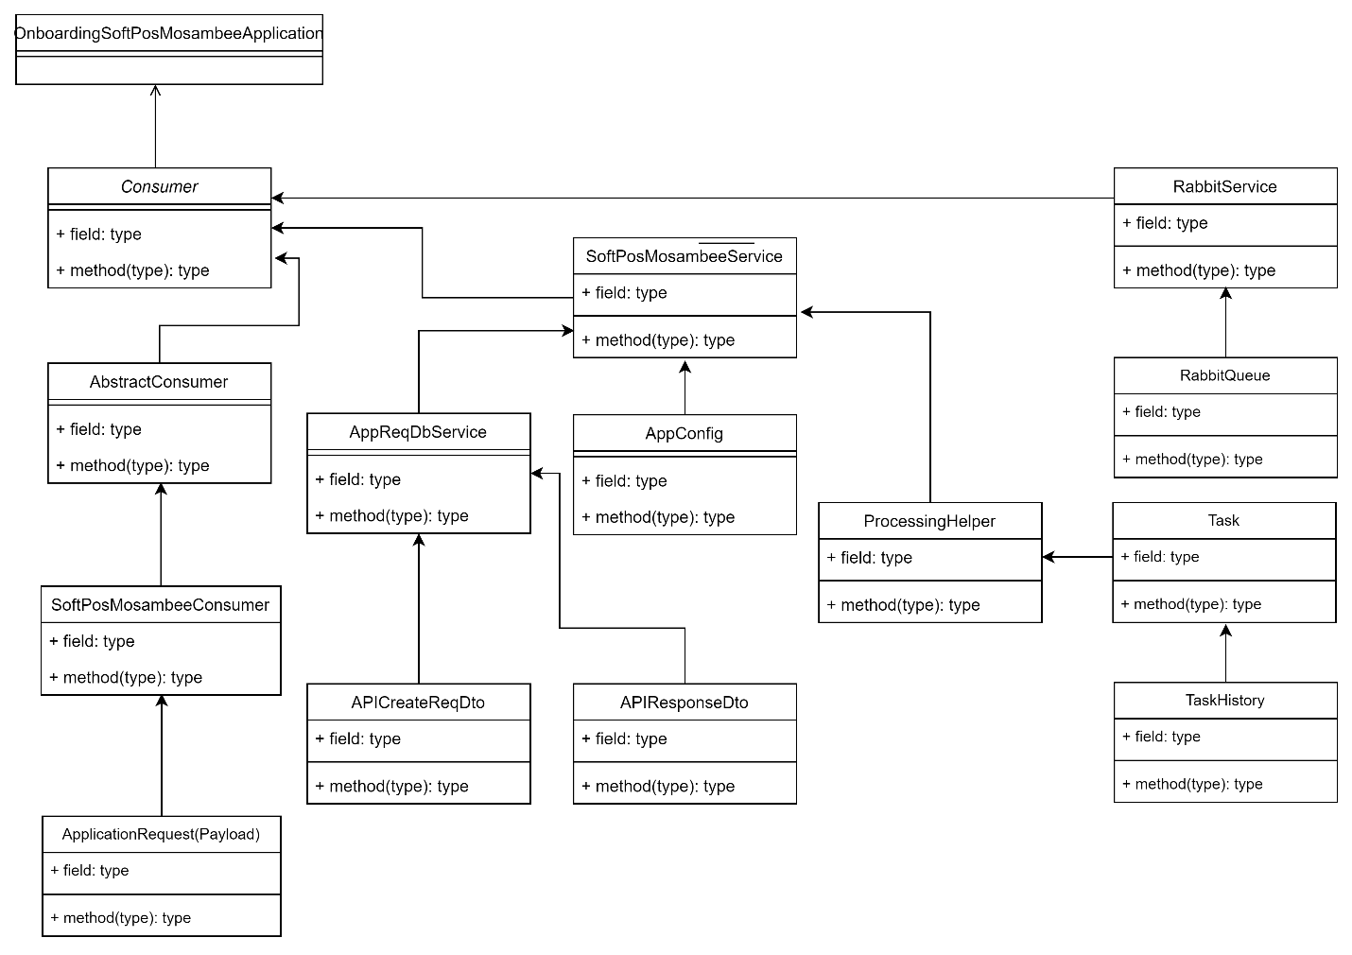

Use Cases

Adding a merchant

Mosambee supports following JSON API features,
1. Business profile API.
1. Merchant Setup API.
2. TID Setup API.

Authentication

Softpos Mosambee provides JSON based rest API connectivity to the client for integration with configuration (merchant profile, MID and TID setup) service.
Adapter integrating with Mosambee APIs with the following technologies
1. Invoking the HTTPS API request using JSON payload.
2. HMAC generation.

API Parameter Specification
JSON API should include the following request headers and payload (request body) parameters as per the requirement. Any invalid parameters will be ignored, or request discarded by service.

Request Header:
Parameter | Type | Description | Mandatory
clientId | String | API client reference number. | Y
dateTime | Timestamp | Timestamp including milliseconds | Y
hmac | String | Generated HMAC value of request payload. | Y

clientId: Shared by Synergistic Financial Networks Pvt. Ltd (Mosambee) with client after successful setup of client in API platform system.
dateTime: timestamp in milliseconds. Ex – 1655780920129, if date time is Tuesday, June 21, 2022 3:08:40.129 AM
hmac: Client generate HMAC with shared secret key and request body payload.
algorithm: HmacSha512
hmac = encodeBase64(hmac(‘clientId + datetime +request payload’, ‘secret key’))

Request Payload:
Parameter | Type | Description | Mandatory
clientId | String | Client reference or identifier value provided by Mosambee. | Y
encRequestMsg | String | Encrypted value of request payload. Refer API section for fields detail. | Y

Request Payload Encryption:
Each request JSON object or array is encrypted using symmetric key and generated cipher text value will be the final data used in encRequestMsg field.

Algorithm: AES, Mode: GCM, Padding: NoPadding, Key Size: 256 Bits

API Specification - Merchant (Profile, MID and TID) Setup API
This API allow client to configure merchant code (MID) and TID and merchant setup with existing merchant profile.
HTTP Method: POST API: //v1/merchant/profile/registration
Content Type: application/json
Accept: application/json

Request Sample:
{
"businessLegalName": "Spice resturent and bar",
"businessDbaName": "Spice group of company",
"businessContactNumber": "9800980777",
"businessEmail": "info@spice.com",
"businessSpocName": "Josep",
"businessAddress": "99 Feet Street, Abuzz Plaza, Mumbai",
"businessCity": "Mumbai",
"businessState": "Maharastra",
"businessPin": "400001",
"businessCategoryCode": "5499",
"midDetails":
{
"merchantCode": "100234",
"instrument": "card",
"acquirer": "HDFC",
"tg": "YES",
"tidDetails": [
{
"terminalId": "101420",
"userName": "7777696",
"tidType": "221300",
"terminalLocation": "pune",
"posTerminalSupport": "CPOC",
"devicePairFlag": "N",
"terminalAuthType": "none",
"terminalSpocName": "David",
"terminalContactNo": "7858589656",
"terminalEmail": "reliance@sales.com"
}
]
}
}

Response Parameter
{
"result": "success",
"responseCode": "00",
"message": "merchant profile created successfully.",
"merchantRefNo": "2356" ,
"midDetails": {
"responseCode": "00",
"message": "mid configured successfully.",
"midRefId": "100234",
"tidDetails": [
{
"responseCode": "00",
"message": "tid configured successfully.",
"terminalId": "101420",
"userName": "7777555696",
"tidRefId": "221300"
}
]
}
}

Response Code
Below are the response code and the reason description for the response in order the API calls
performed.
Value | Description
00 | API operation successful
10 | Message authentication failed.
11 | Invalid clientRefId.
12 | Invalid acquirer or tg value.
13 | TID detail is mandatory
14 | Terminal id already exists
15 | Username already exists.
16 | Merchant code already exist for another merchant
17 | Merchant profile not active for MID or TID configuration
18 | Card instrument already configured

Deployment Diagram

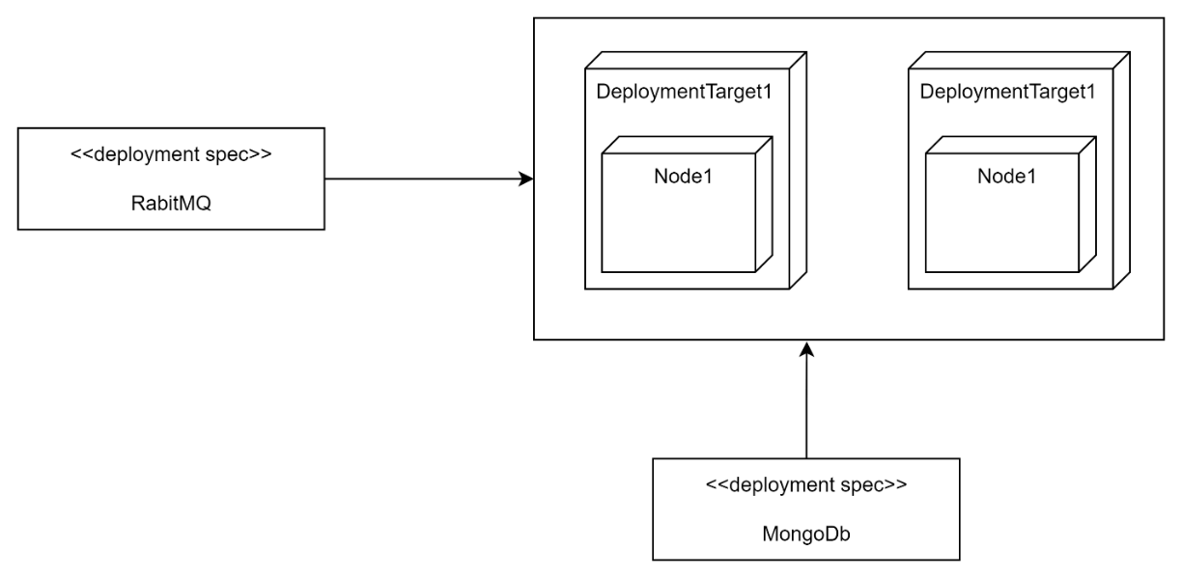

Other Interfaces
Identify any external interfaces used in the execution of this module, include technology and other pertinent data

Interface X
Message details describe in attached file

Outstanding Issues
- Outstanding Issue - Get/Query for Merchant / Business profile / Terminal details – This is not included, since requirement and payload structure is not finalized yet

Non Functional Requirement
Non-Functional Requirement | Definition
Maintainability | Ease to change and evolve with minimal effort
Security | Encryption, password controls, storing and handling of personal and sensitive data
Testability | Ease to confirm conformance by observing a reproducible behavior
Portability | Ease to reuse for multiple platforms
Extensibility | Ease to takes into consideration future growth
Whitelisting Domain/Ips | NI’s domain and IP should be whitelist into SoftPos Mosambee before deployments in production

References

Glossary
Acronym | Full form
NI | Network International
MQ | Message Queue
API | Application Program Interface
MID | Merchant Identification
TID | Terminal Identification

